Glennville Round-up Rodeo Marketplace
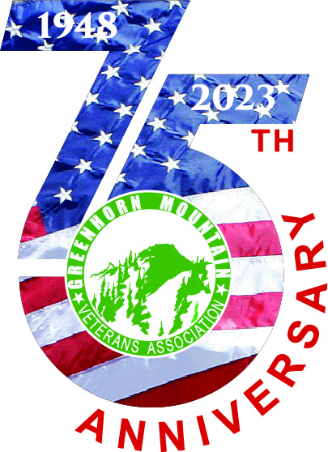
Vendor Application

NAME: _______________________________________________________________________________________________
ADDRESS: ___________________________________________________________________________________________
CONTACT INFO: _____________________________________________________________________________________
EMAIL: _______________________________________________________________________________________________
BRIEF DESCRIPTION OF ITEMS: ____________________________________________________________________
SIZE OF BOOTH NEEDED: 10 x 10 _________$150.00
10 x 20 OR TRAILER__________$250.00
This is a 3-day event, you can come in on Thursday and setup anytime after 2pm. There will be free dry camping behind the rodeo grounds. Booth spaces will be assigned.
- To reserve your space, it must be paid in advance – no late than May 10, 2023
NO REFUNDS
- Make check payable to either Susie Ray or GMVA
- Checks can be mailed to Susie Ray (P.O. Box 474 Glennville, CA 93226)
- Or you may leave check or cash & application at Fred C. Gilbert Farm & Ranch Supply
- Questions? Call Susie Ray @ 559-310-3753
FRIDAY: The Queen’s will be having their event and there will also be a Ranch Rodeo.
Your booth will need to be set up and your vehicles parked and out of the way by 10am until?
SATURDAY: There will also be a Ranch Rodeo. You will need to set up by 9AM until?
SUNDAY: Cowboy Church 9AM, Parade 11AM, Rodeo at 1PM. Set up by 8:30AM until?
On both Friday & Saturday evening there will be a concert between the eating area and the vendor grassy area. It is your option to stay open.
    - NO ELECRICITY AVAILABLE-You will need your own lights & generator
- There will also be a Chuck Wagon Style Dinner (Price will be available at a later date)
- Concert with Joe Peters
- No wrist bands available, they must be purchased at the ticket booth. (Sorry for any inconvenience)

X____________________________________________ ____________________________
SIGNATURE DATE

